Why you always inspect data visually (graphing) and statistically (mean, STDEV, variance, etc.): Anscombe’s Quartet
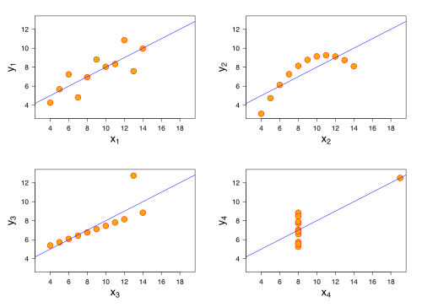

These four datasets have the same mean, variance, correlation and regression line, but mean very different things, right?

